**Lab 4: Python Hadoop Streaming**

**Write down the commands and paste the corresponding screenshots in the following:**

**Task 1: Execute the map and reduce python scripts at University Hadoop System.**

1). Change the execution permission of the python files.

chmod +x max_temperature_map.py

chmod +x max_temperature_reduce.py

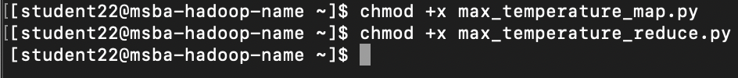

2). Test the two python files locally before running them using Hadoop.

echo "0067011990999991950051507004+68750+023550FM-12+038299999V0203301N00671220001CN9999999N9+00001+99999999999" | /home/student22/max_temperature_map.py



echo "0067011990999991950051507004+68750+023550FM-12+038299999V0203301N00671220001CN9999999N9+00001+99999999999" | /home/student22/max_temperature_map.py | sort -k1,1 | /home/student22/max_temperature_reduce.py

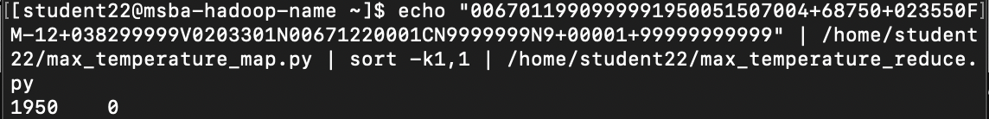

3). Copy the sample data to HDFS and Execute the mapper and reducer using Hadoop streaming.

cat sample.txt | /home/student22/max_temperature_map.py

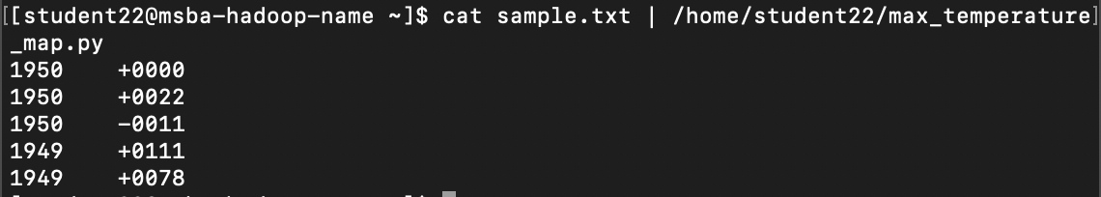

cat sample.txt | /home/student22/max_temperature_map.py | sort -k1,1 | /home/student22/max_temperature_reduce.py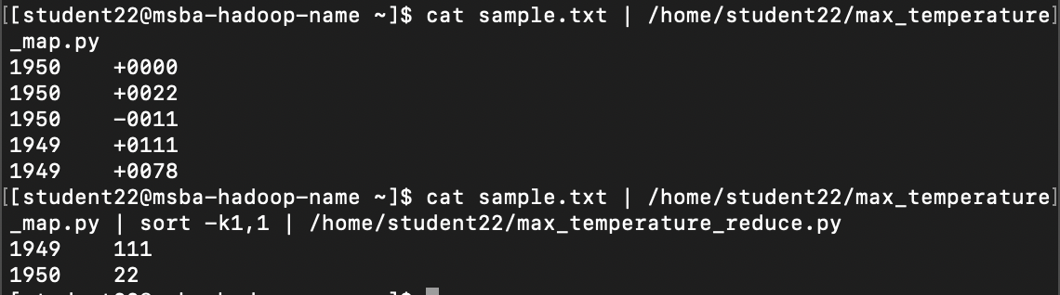

4). Find the print out the final output.

**Task 2: Execute the map and reduce python scripts at AWS EMR.**

1). Paste a screenshot of streaming before adding the step;

2). Paste the output directory screenshot;

3). Open the output file and paste the screenshot of content from the output file.

